**Lesson Notes**

1. What is the main purpose of an Operating System?

a. Handles system handles computer hardware and resources allocation, provides standard user interface and a standard way to store/browse data, and it allows multiple applications to run at once.

2. What is the difference between Operating System Software and Use Application Software?

a. Applications just ask for what they need (e.g. Memory, Disk Space) but operating System checks for availability and access permission. Also, applications focus on what is contained and displayed within a window whereas operating System controls opening / closing / resizing windows and responding to mouse and keyboard actions

3. What is the difference between Operating System Software and Computer Hardware?

a. Same applications can run on different computer hardware whereas operating System must be configured according to hardware components present in the computer

b.

4. What are the main parts of an Operating System?

a. Graphical User Interface (GUI)

b. System Calls

c. Device Drivers

d. I/O Manager

e. Memory Manager

f.  Process Manager

g. Security Monitor

5. What are some popular operating systems?

a. Windows OS

b. Mac OS

c. Linux / Unix

d. Android

e. iOS

**Reference Diagram**

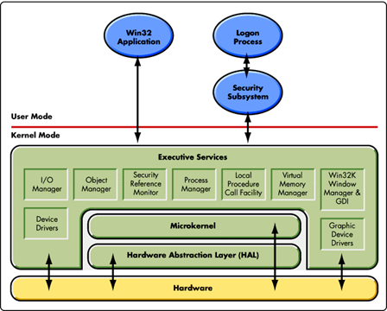

|  |  |
| --- | --- |
|  |  |

**Student Questions**

1. What is a device driver?

a.    Provide a brief summary

                                          i. A device driver is a software program that controls a particular type of hardware device that is attached to a computer. When buying an operating system, many device drivers are built into the product

b.    List some devices that require a device driver.

                                          i. Some devices include printers, displays, CD-ROM readers, network or sound cards, computer mice or hard disks.

c.     Provide a label on the reference diagram for the location of a device driver for your

graphics card.

d.    Provide a label on the reference diagram for the location of a device driver for a locally attached printer.

2. What is a DLL?

a.    Provide a brief summary

Dynamic-link library (DLL) is Microsoft's implementation of the shared library concept in the Microsoft Windows and OS/2 operating systems. These libraries usually have the file extension DLL, OCX (for libraries containing ActiveX controls), or DRV (for legacy system drivers). The file formats for DLLs are the same as for Windows EXE files – that is, Portable Executable (PE) for 32-bit and 64-bit Windows, and New Executable (NE) for 16-bit Windows. As with EXEs, DLLs can contain code, data, and resources, in any combination.

b.    Explain how DLLs are related to user application programs

Data files with the same file format as a DLL, but with different file extensions and possibly containing only resource sections, can be called resource DLLs. Examples of such DLLs include icon libraries, sometimes having the extension ICL, and font files, having the extensions FON and FOT.

*c.* Provide a label on the reference diagram for the location of a DLL

3. What is a windows manager?

a.    Provide a brief

      i. A window manager is system software that controls the placement and appearance of windows within a windowing system in a graphical user interface.

b.    Explain how a windows manager is related to user application programs

 i. Most window managers are designed to help provide a desktop environment. They work in conjunction with the underlying graphical system that provides required functionality—support for graphics hardware, pointing devices, and a keyboard, and are often written and created using a widget toolkit.

c.     Provide a label on the reference diagram for the location of a DLL

4. What is the windows task manager?

a.    Provide a brief summary

                                          i. The Windows Task Manager is a powerful tool packed with useful information, from your system’s overall resource usage to detailed statistics about each process.

b.    List and explain four (4) types of system information provided by the task manager

i. Users

ii. Details

 iii. App history

iv. Performance

c.     Provide a label on the reference diagram for the operating system components related to each type of information.